Project Name: Docker Swarm - Voting application
Objective | To deploy a scalable, multi-service voting application on a manager node,  ensuring efficient orchestration, fault tolerance, and seamless monitoring  through Docker visualizer
Problem Statement and Motivation | John, a DevOps engineer, is tasked with deploying a voting application  through multiple microservices. By creating a Docker compose file and  deploying it on a manager node in a distributed system, they ensure that  each service is efficiently orchestrated and fault-tolerant.  To monitor the deployment, John integrates Docker visualizer as a  microservice, providing real-time insights. This setup simplifies the  deployment process, enhances scalability, and ensures the application runs  smoothly in a production environment.
Create EC2 instances | 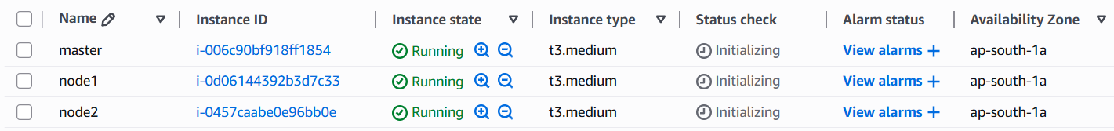
  node | public-ip | private-ip
  master | 13.201.36.209 | 172.31.37.63
  ndoe1 | 15.206.73.200 | 172.31.32.63
  node2 | 13.127.206.197 | 172.31.42.250
Connect each server | ssh -i 002.pem ubuntu@13.201.36.209  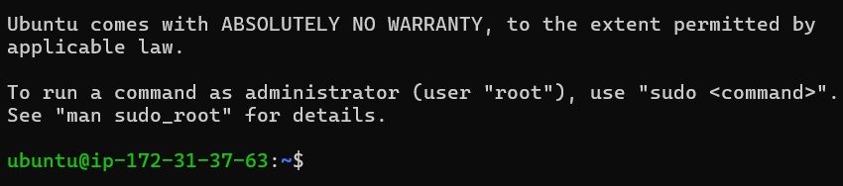
Install docker on all 3 instances | sudo apt update -y  sudo apt install docker.io -y  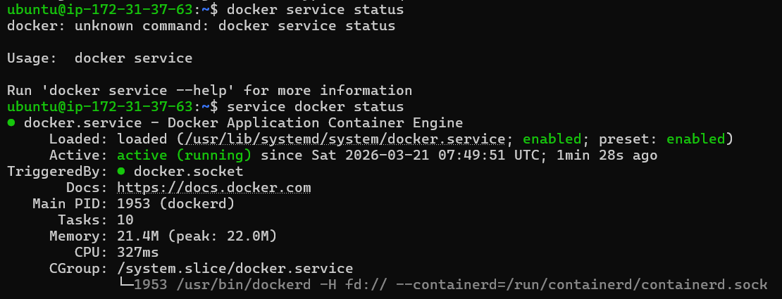
Install docker swarm on master node | # master: 172.31.37.63  docker swarm init --advertise-addr 172.31.37.63  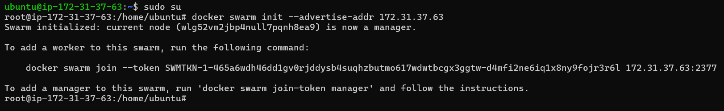  #note down node join command
join node1 and node2 in swarm cluster | #node join command. Run below command on node1 and node2  docker swarm join --token SWMTKN-1-465a6wdh46dd1gv0rjddysb4suqhzbutmo617wdwtbcgx3ggtw-d4mfi2ne6iq1x8ny9fojr3r6l 172.31.37.63:2377
Swarm cluster nodes | 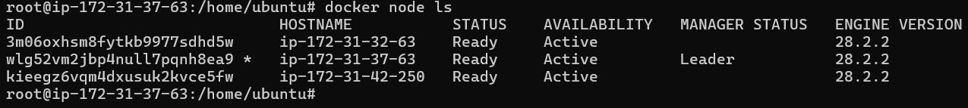
overview of voting website | - Home page with 4 political party buttons  - Vote page that saves the vote in a free MySQL database  - Results page to see totals  - Uses PHP + MySQL (works on free hosting like InfinityFree, 000webhost, or Hostinger free plans)
Structure: | voting-app/  ├── Dockerfile  ├── index.php  ├── vote.php  ├── results.php  └── db.php
Dockerfile | FROM php:8.2-apache  RUN apt update -y  RUN apt install git -y  RUN git clone https://github.com/pradeepviswa/voting-app.git /var/www/html  RUN ls /var/www/html  RUN docker-php-ext-install mysqli  #check mysqli  RUN php -i | grep mysqli
Dockerfile | 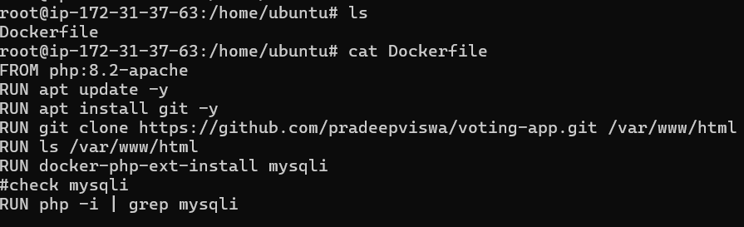
Build Docker Image | docker build -t voting-image .  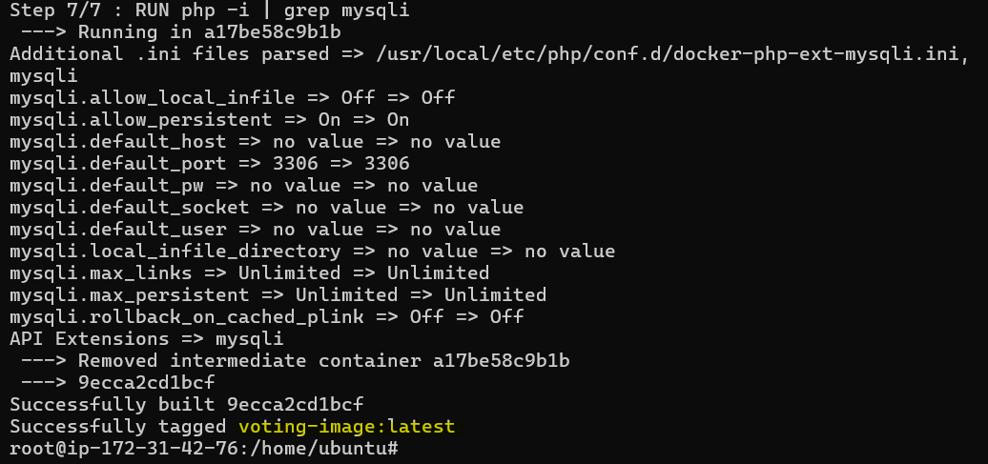
Create Overlay Network | docker network create \  --driver overlay \  voting-network  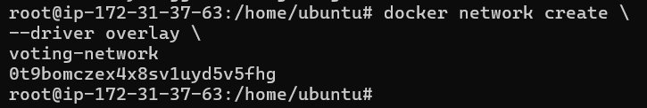
Check new network | docker network ls  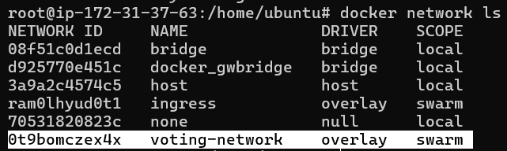
Create MySQL Service | docker service create \  --name voting-mysql \  --network voting-network \  -e MYSQL_ROOT_PASSWORD=root \  -e MYSQL_DATABASE=voting_db \  mysql:8  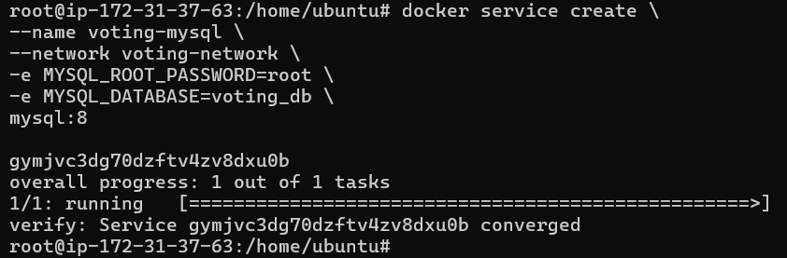
Create Web Service | docker service create \  --name voting-web \  --network voting-network \  -p 8080:80 \  voting-image  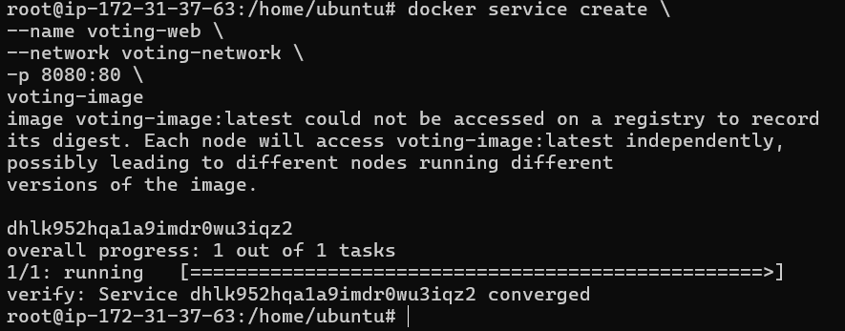
Check service: | docker service ls
Docker containers | docker ps
Container IDs | 18d0c2bb861f voting-image:latest  fd0eeb1dcb93 mysql:8
Ping voting-mysql from voting-web
  Connect voting image container | docker exec -it 18d0c2bb861f /bin/bash  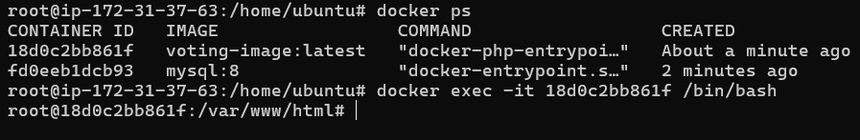
  Install ping utility | apt install iputils-ping  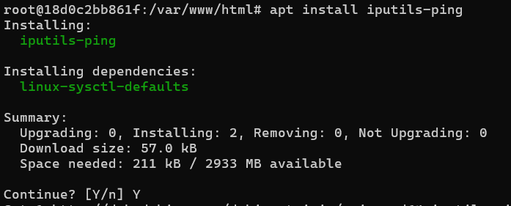
  ping voting-mysql | ping voting-mysql  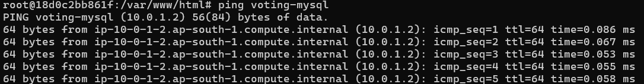
Database Connection  [info] | My db.php uses the service name as hostname:  $host = "voting-mysql";  Swarm DNS automatically resolves the service as shown above.
Enter MySQL Service to Create Table
  get container ID: | docker ps  fd0eeb1dcb93 mysql:8
  Connect mysql:  #password is root | docker exec -it fd0eeb1dcb93 mysql -u root -p  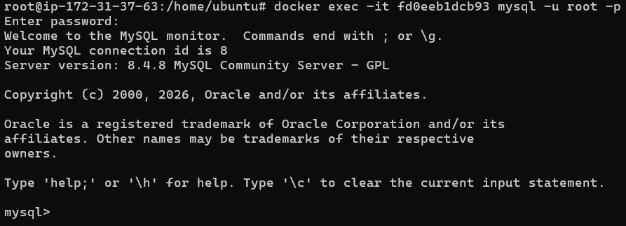
  Create table: | USE voting_db;  CREATE TABLE votes (  id INT AUTO_INCREMENT PRIMARY KEY,  party VARCHAR(50)  );  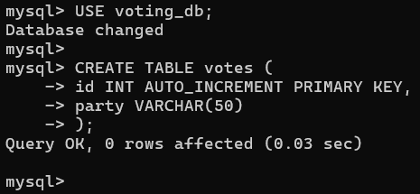
Scale the Web Service (Swarm advantage) | docker service scale voting-web=3  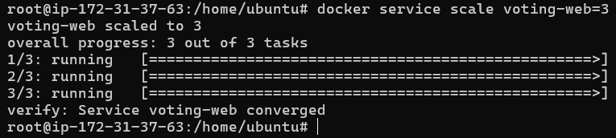
Access web stie | http://13.201.36.209:8080/  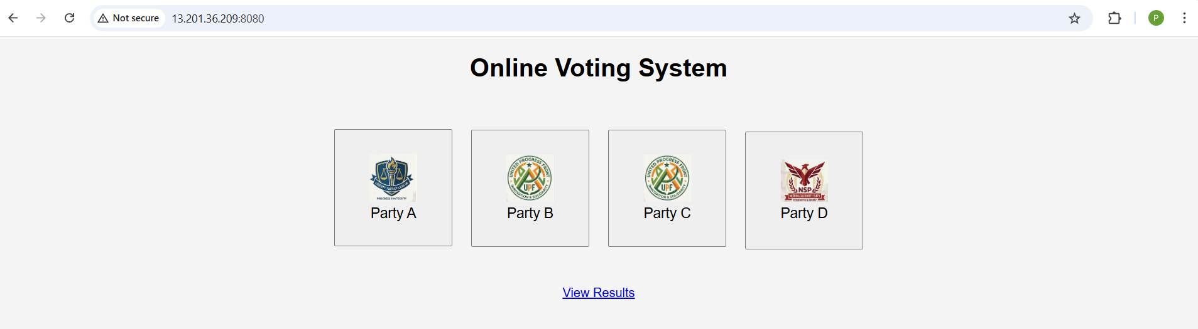
Docker Visualiszer | Docker Visualizer does not communicate over container networks.  It reads Docker data via:  /var/run/docker.sock
Deploy Docker Visualizer as a service | docker service create \  --name=visualizer \  --publish=9090:8080 \  --constraint=node.role==manager \  --mount type=bind,src=/var/run/docker.sock,dst=/var/run/docker.sock \  dockersamples/visualizer  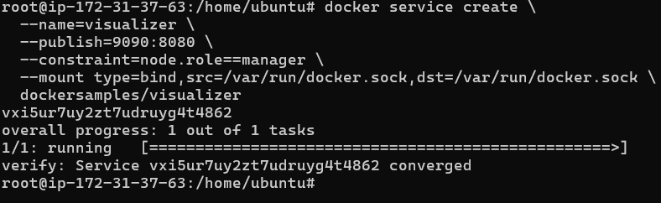
Access visualiser | http://13.201.36.209:9090/  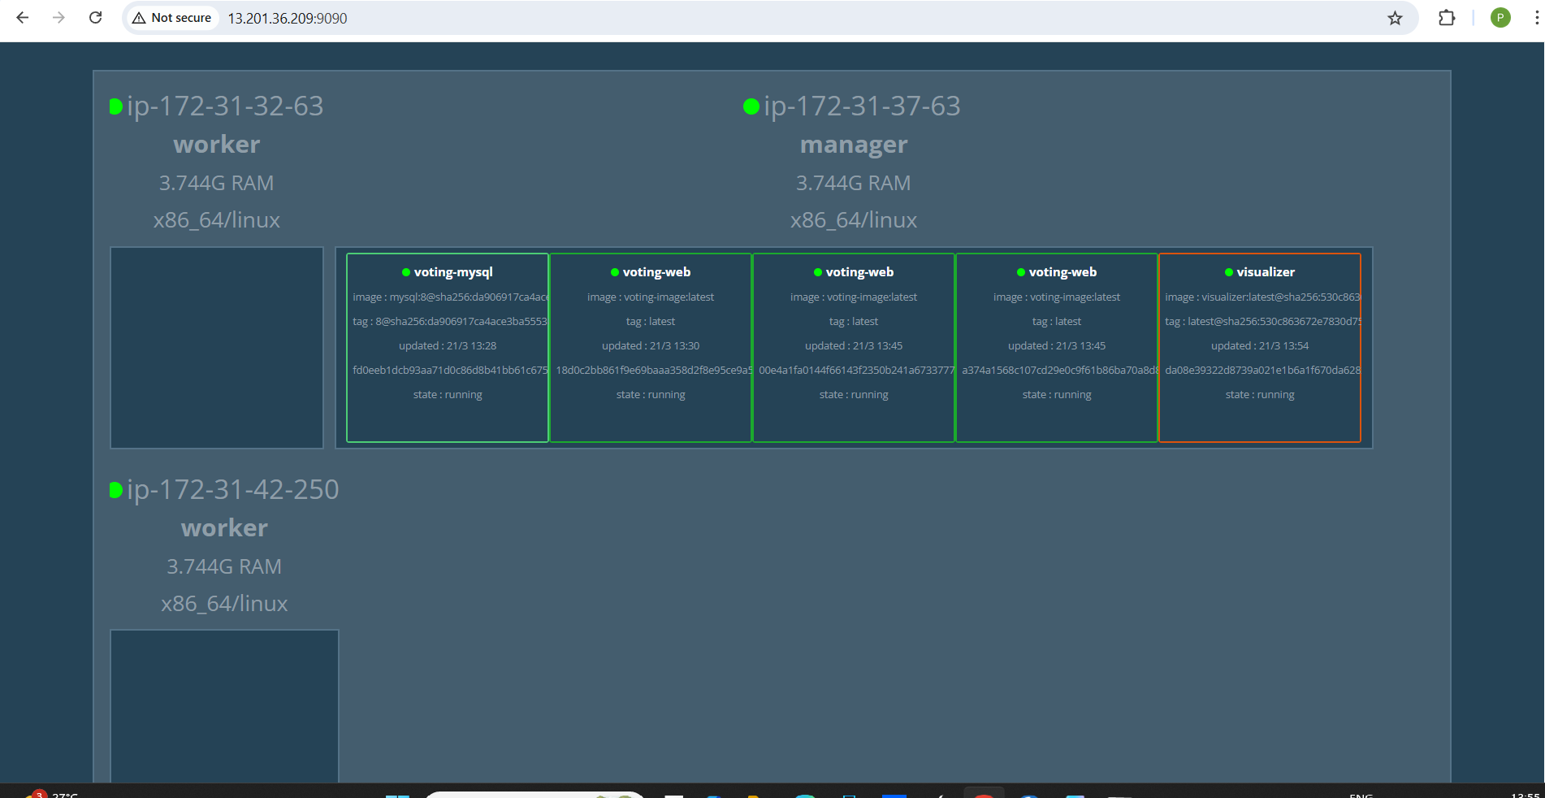

Output:

Open Website  And  Click on different buttons multiple times | 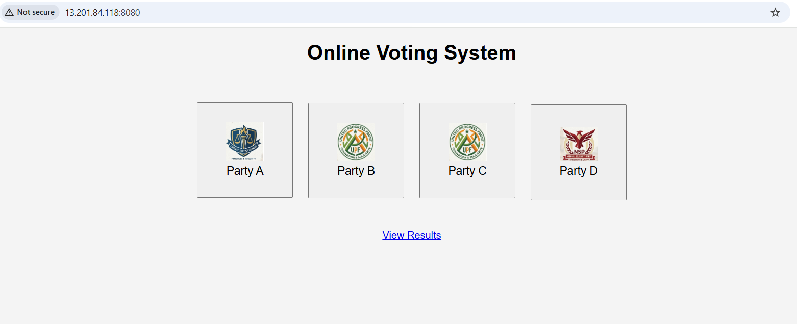
When clicked on any button here is the output | 
See Results page | 

How voting app website is configured?
Git location | https://github.com/pradeepviswa/voting-app.git
db.php | <?php  $host = "voting-mysql";  $user = "root";  $password = "root";  $database = "voting_db";  $conn = new mysqli($host,$user,$password,$database);  if ($conn->connect_error) {  die("Connection failed: " . $conn->connect_error);  }  ?>
index.html | <!DOCTYPE html>  <html>  <head>  <title>Online Voting System</title>  <link rel="stylesheet" href="style.css">  </head>  <body>  <h1>Online Voting System</h1>  <div class="container">  <form action="vote.php" method="POST">  <button name="party" value="Party A">  <img src="img/party1.png"><br>  Party A  </button>  <button name="party" value="Party B">  <img src="img/party2.png"><br>  Party B  </button>  <button name="party" value="Party C">  <img src="img/party3.png"><br>  Party C  </button>  <button name="party" value="Party D">  <img src="img/party4.png"><br>  Party D  </button>  </form>  <br><br>  <a href="results.php">View Results</a>  </div>  </body>  </html>
results.php | <?php  include "db.php";  ?>  <!DOCTYPE html>  <html>  <head>  <title>Voting Results</title>  </head>  <body>  <h1>Voting Results</h1>  <?php  $parties = ["Party A","Party B","Party C","Party D"];  foreach($parties as $p){  $result = $conn->query("SELECT COUNT(*) as total FROM votes WHERE party='$p'");  $row = $result->fetch_assoc();  echo "<h3>$p : ".$row['total']." votes</h3>";  }  ?>  <br>  <a href="index.html">Back to Vote</a>  </body>  </html>
style.css | body{  font-family: Arial;  text-align:center;  background:#f4f4f4;  }  .container{  margin-top:50px;  }  button{  width:150px;  height:150px;  margin:10px;  font-size:18px;  cursor:pointer;  }  img{  width:60px;  }
vote.php | <?php  include "db.php";  if(isset($_POST['party'])){  $party = $_POST['party'];  $sql = "INSERT INTO votes (party) VALUES ('$party')";  $conn->query($sql);  echo "<h2>Thank you for voting!</h2>";  echo "<a href='results.php'>See Results</a>";  }  ?>
Image files here | img/party1.png  img/party2.png  img/party3.png  img/party4.png

